**QSIM Configuration Instructions**

How to Enroll EGM 2

Configure EGM with a valid serial number 2

EGM Configuration 2

Game Configuration 2

How to enable External Jackpots 3

Enable External JP Icon only 3

Enable External JP Message only 3

Enable Both External JP Icon and Message 3

How to set up Linked Jackpot parameters 4

How to perform a HMAC HASH request 6

How to set SAP JP Ceiling values (RAM Clear Required) 7

How to perform Denomination Hot-Switching 7

How to perform Variation Hot-Switching 7

How to enable Reserve 7

How to enable Autoplay 7

How to enable PID 7

How to enable SPAM messaging 8

SPAM A 8

SPAM B 8

How to enable GPM messaging 8

How to determine the SAP HRATE via QSIM 8

How to transfer cash in to EGM from QSIM 8

How to clear (toggle) a MEF lockup 9

How to clear (toggle) a GEF lockup 10

How to clear a NOPOLL lockup 10

How to clear an Event Queue Full Lockup 10

# How to Enroll EGM

## Configure EGM with a valid serial number

Configure on the EGM a valid serial number. (Cannot be 000000)

Once the game is running on the EGM and connected to the simulator perform the following:

## EGM Configuration

EGM 🡪 Configure 🡪 EGMCfgPoll 🡪

***Values that need to be set:***

**JUR** *[QLD Club = 00, QLD Casinos = 01, NZ Class = 02, TAT = 03]*

**DEN**

**TOK** *[Check from Game Profile. for NZ Class, it is 200 cents]*

**Q. EGMCP** *[To apply the changes]*

## Game Configuration

EGM 🡪 Configure 🡪 Game Cfg 🡪

***Values that need to be set:***

**GVN** *[Auto-populated]*

**VAR**

**PGID** *- 0xFFFF for non-progressive or SAP only games;*

*- Any value between 0x0001 - 0xFFFE for LP only games (Note: this number will be used to create the Link Progressive Pools in the simulator to get the link game running)*

**Levels** *[For each JP level supported, b7 needs to be unchecked for SAP and it needs to be checked for LP jackpot. QLD SAP JP Start Ups can be set from here.]*

**Q. EGMGCP** *[To apply the changes]*

# How to enable External Jackpots

## Enable External JP Icon only

EGM 🡪 Configure 🡪 MORE 🡪 MORE 🡪 EXTJIP Menu 🡪 EXTJIP OTHER 🡪 set any value 🡪 enter 🡪 Un-check All options 🡪 Accept 🡪 Check b0- Icon ID option (*to enable external JP icon*) 🡪 Accept 🡪 enter progressive levels 🡪 Q. ExJIP

## Enable External JP Message only

EGM 🡪 Configure 🡪 MORE 🡪 MORE 🡪 EXTJIP Menu 🡪 EXTJIP OTHER 🡪 set any value 🡪 enter 🡪 Check b7-Display (*to enable external JP message*) 🡪 Accept 🡪 Un-check all options 🡪 Accept 🡪 enter progressive levels 🡪 Q. ExJIP

## Enable Both External JP Icon and Message

EGM 🡪 Configure 🡪 MORE 🡪 MORE 🡪 EXTJIP Menu 🡪 EXTJIP OTHER 🡪 set any value 🡪 enter 🡪 Check b7-Display (*to enable external JP message*) 🡪 Accept 🡪 Check b0-Icon ID (*to enable external JP icon*) 🡪 Accept 🡪 enter progressive levels 🡪 Q. ExJIP

# How to set up Linked Jackpot parameters

1. ***Ensure that the PGID in Game Configuration Poll is set to a number between 0 x0001 and***

***0 xFFFF***

1. ***Define Linked Progressive Parameter in QSIM***

* From the simulator, MAIN MENU 🡪 LINK PROGR 🡪 Define/Change 🡪 Enter a PGID (PGID must be the same as the PGID defined in step 1).
* Enter the Progressive level Number to be configured (Between 0 and 7, Level 0 must be the highest jackpot).
* Level Number : 0 🡪 Enter (Level 0 is used in this example, if it ask to replace select yes)
* Enter the Level Name ( 20 chars Max & no spaces) Name : Grand 🡪 Enter
* Enter the SUP ($.c) : 50,000.00

*/* Use the Jackpot Start Up values from the Jackpot Calculations */*

* Enter the Percentage Increment for the level (%) Increment : 0.10%

*/* Use the Increment value from the Jackpot Calculations */*

* Enter the Ceiling ($.c) : 50,000.00 🡪 Enter

*/* Increment rate and the Ceiling values will be based on Jackpot Calculations */*

* Enter the Current TURNOVER towards Jackpot ($.c) : 200.00 🡪 Enter (any value you want, this will be added on top of the initial startup values)
* Repeat the above steps for each of the other jackpot levels as required.

**How to perform Linked jackpot credit transfer and handpay**

If jackpot win amount < AutoPay amount then JP win amount transfer to Credit meter, if it is not then it will be a Handpay.

Use ‘{’ and ‘}’ keys from Keyboard to choose desired JP Level.

MAIN MENU 🡪 LINK PROGR 🡪 Set AutoPayAmt 🡪 Enter the AutoPay Threshold (> JP Amount) for selected level 🡪 Enter

Repeat for other jackpot levels.

Win a JP less than the AutoPayAmt, The amount will be transferred to Credit Meter.

Win a JP greater than the AutoPayAmt, The amount will be a Handpay.

**Manually clear a Jackpot win via QSIM**

MAIN MENU 🡪 LINK PROGR… 🡪 Auto Prg Reset (Press Enter to choose **OFF)**

Once win a Linked Jackpot, EGM will display a message “VERIFYING JACKPOT AMOUNT=$400.00”. EGM locks up at this stage; it needs to be clear manually.

MAIN MENU 🡪 LINK PROGR.. 🡪 Q LP Ack Poll (This will clear the lockup).

**Set “Auto Clear” Jackpot win via QSIM**

MAIN MENU 🡪 LINK PROGR… 🡪 Auto Prg Reset (Press Enter to choose **ON)**

Once win a Linked Jackpot, EGM will display a message “VERIFYING JACKPOT AMOUNT=$400.00”. This message will clear automatically and EGM will not lock up at this stage.

# How to perform a HMAC HASH request

***From QCom Simulator:***

* The Deploy (Release) version of the game **must** be used.
* EGM 🡪 Program Hash 🡪 Request + Seed

The QCOM HMAC HASH will be reported in the communications display window of the simulator.

***Using QCOM Hash Calculator:***

* Open QCOMHashCalc.exe program
* Drag over the deploy version of game signature file [GameID.sigs]
* Drag over the deploy version of the platform signature [platform.sigs] ( Locate from Submission folder. e.g. O:/Technical Compliance\Submissions\Pc4_sub\NZClass4_pc4_sub\Kernel_03A\P4NZQ03A\sig file)
* 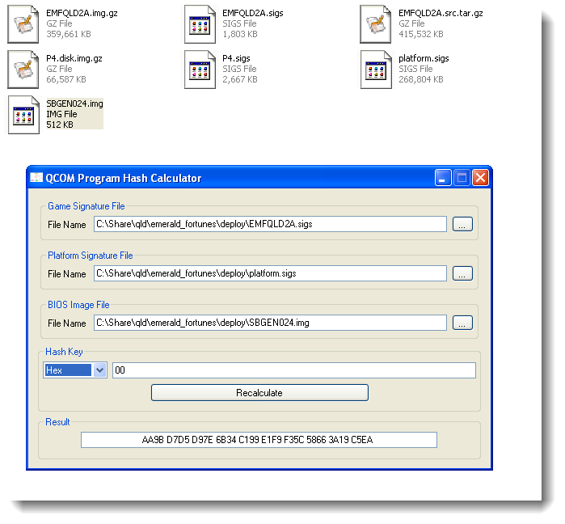Drag over BIOS image file [e.g. SBGEN024.img]. Copy this image from Buildserver.
* Result will be shown in “Result” field.

Figure 1

# How to set SAP JP Ceiling values (RAM Clear Required)

EGM 🡪 Configure 🡪 Game Cfg 🡪 Levels 🡪Progr Level 🡪 Accept 🡪 set Initial Current Amount for the number of levels supported by your game 🡪Back 🡪 Q. EGMGCP

*[If Default Start up of a JP is $200 and you set Initial Current Amount as $10, Start Up value of that JP will be $210 (=$200+$10)]*

***Note:*** *JP Ceiling Values cannot be set through QCom for New Zealand Class4 market.*

# How to perform Denomination Hot-Switching

*EGM Credit Meter should be zero.*

**Disable machine:** EGM 🡪 Configure 🡪 EGM Cfg Req 🡪 Uncheck b5 (MEF) 🡪 Return 🡪 Q EGMCRP

**Change Denomination:** EGM 🡪 Configure 🡪 EGMCfgPoll 🡪 DEN 🡪change DEN 🡪 Q EGMCP

**Enable Machine:** EGM 🡪 Configure 🡪EGM Cfg Req 🡪 check b5 🡪return 🡪 Q EGMCRP

# How to perform Variation Hot-Switching

*EGM Credit Meter should be zero.*

EGM 🡪 Configure 🡪 More 🡪 GCCP Poll 🡪 VAR 🡪 Change Variation 🡪 Q GCCP

# How to enable Reserve

EGM 🡪 Configure 🡪 More 🡪 Param Poll.. 🡪FLG 🡪 Select b5*Res featv1 🡪Accept 🡪 Q EGMPP

# How to enable Autoplay

EGM 🡪 Configure 🡪 More 🡪 Param Poll 🡪 FLG 🡪 check b6 (autoplay) 🡪 Accept 🡪 Q EGMPP

# How to enable PID

EGM 🡪 Configure 🡪 more 🡪 Param Poll 🡪 more 🡪 PID 🡪 03* 🡪 Q. EGM PP

\**00 disables the PID*

*\*01 denotes QLD version PID*

*\*02 denotes Tattersalls version PID*

*\*03 denotes NZ Class version PID*

# How to enable SPAM messaging

This poll is used to display various text messages to patrons and attendants. Up to two messages at once (denoted A & B) must be maintained by the EGM via these polls.

## SPAM A

EGM 🡪 MORE 🡪 SPAM 🡪 SPAM A 🡪 <*b6> + <*b7> 🡪 Accept 🡪 <enter a message here or press enter for default message> 🡪 Q SPAMAP

*Selecting b6 will enable the prominence flag, this will cause the SPAMA message to be prominently displayed in the middle of the screen when the EGM is in idle state.

*Selecting b7 will enable the fanfare flag, this will play a short musical tune when SPAM A poll is sent.

## SPAM B

**Message B (will be display the message at the bottom of the EGM screen):**

EGM 🡪 MORE 🡪 SPAM 🡪 SPAM B 🡪 <*b7> 🡪 Accept 🡪 <enter a message here or press enter for default message> 🡪 Q SPAMAP

*Selecting b7 will enable the fanfare flag, this will play a short musical tune when SPAM B poll is sent.

# How to enable GPM messaging

This extended broadcast type requests the EGM to display an arbitrary text message to the player while it is in idle mode.

BROADCASTS 🡪 More 🡪 More 🡪 Gen Promo Msg 🡪

FMT = 80 (If set to 80, the EGM must also make a short attention sound)

General Promotional Message Text Data = message to be shown (Maximum length is 80 bytes)

# How to determine the SAP HRATE via QSIM

EGM 🡪 MAINTAINANCE 🡪 GEN MAINT 🡪 GEN Maint Poll 🡪 Accept 🡪 Accept 🡪 type current variation 🡪 Check b7, b5 🡪 Accept 🡪 enter 🡪 enter 🡪 Q EGMGMP

* Match HRATE with Calc > PP Jackpot Parameters:

X= (Average Prize – Start Up)/Increment

HRATE = (1/x)/100 (divide by 100 to convert the value as a “per cent”)

# How to transfer cash in to EGM from QSIM

EGM 🡪 More 🡪 Cashless

# How to clear (toggle) a MEF lockup

If the EGM shows a “MEF lockup” message then follow the steps below to clear:

EGM 🡪 Maintenance 🡪 GEN MAINT 🡪 MEF Toggle (this will toggle from disabled state to enabled state, as indicated here )

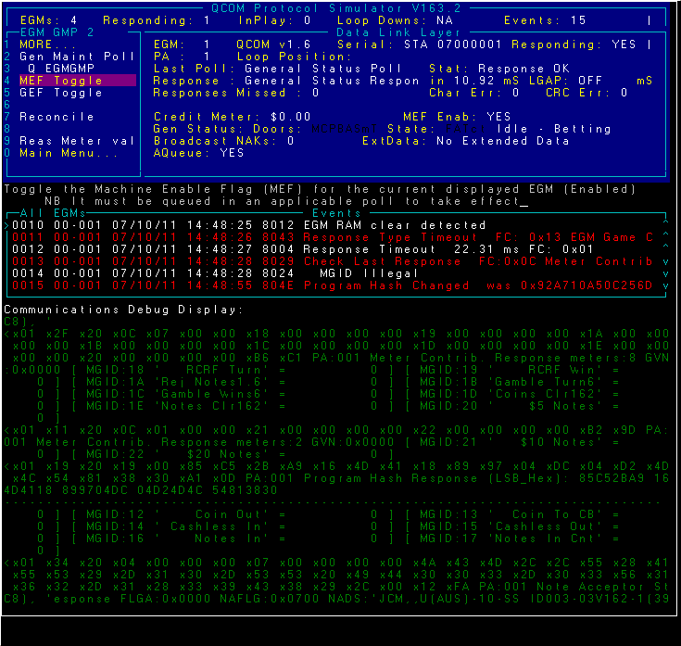

*Screen: To clear MEF Lockup message*

# How to clear (toggle) a GEF lockup

If the EGM shows a “GEF lockup” message then follow the steps below to clear:

EGM 🡪 Maintenance 🡪 GEN MAINT 🡪 GEF Toggle (this will toggle from disabled state to enabled state, as indicated here )

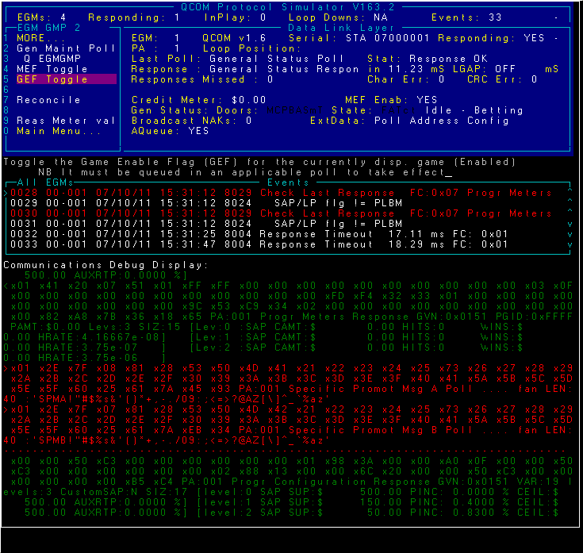

*Screen: To clear GEF Lockup Message*

# How to clear a NOPOLL lockup

EGM 🡪 MORE 🡪 POLLING 🡪 MORE 🡪 No Poll Toggle

# How to clear an Event Queue Full Lockup

EGM 🡪 Events 🡪 Purge EGM Evts